MONTESSORI SPRING SING 2015
BELL - DVD ORDER FORM
ONE FORM PER CLASSROOM

YOUR NAME: ___________________________________________________________________________

YOUR CHILD’S SPRING SING TEACHER: _____________________________________________

YOUR CHILD’S TEACHER IN FALL: ____________________________________________________
(If your student is graduating, your DVD will be available from the school office next fall, sorry – no shipping available.)

NUMBER OF DVDS: ____________________________
(If ordering a DVD from another classroom, please use two forms.)

DVD PACKAGING (Please select one):

*DVD Jewel case $25.00 _________________________________

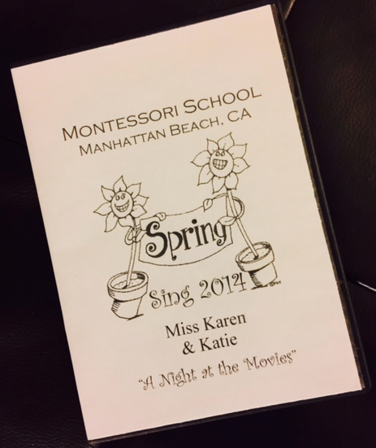

*DVD with Illustrated cover: $30.00 ___________________

MAIL-IN PROCESS: Please mail in this form with cash or a check made out to: Christi McCaverty (not One Love Productions) to 1205 Chestnut Ave, Manhattan Beach, CA 90266

OR

ONLINE PROCESS: Please visit oneloveproductions.net/Mont. You can download forms from this site or order online for only $2.00 more! Please follow the instructions on this page by filling out an electronic order form and submitting a payment via PayPal or Credit Card. You must go through the site and complete both steps. Please do not go directly to PayPal!! Any questions, please contact Christi > cmccaverty@gmail.com

Thank you!
Christi McCaverty
Oneloveproductions.net

